Solution: Partial Page Update

In this lab, you will make several configuration changes in order to improve both application performance and usability by configuring targeted Post On Change for various widgets in TrainingApp.

Requirements

This lab requires that you first complete labs from previous lessons including Creating Entities, Typelists, Editable List View Panels, Introductions to Locations, Create new objects with Popups, and Dependent Drop-downs.

This lab requires that you use TrainingApp 8.0, Guidewire Studio 8.0, and a supported web browser. To view, edit, and delete various contacts, log in to TrainingApp as Alice Applegate. The default URL for TrainingApp is <http://localhost:8880/ab/ContactManager.do>. The login/password for Alice Applegate is aapplegate/gw.

1. Configure targeted Post On Change

In this exercise, you will add a read-only input widget to the ABContactDetailsPersonDV. First, you will configure the widget to display the employer's work phone number for a given person. Next, you will make the necessary configurations so that when the value of the Employer widget changes, the read-only input widget immediately shows the new employer work phone number.

Configuration

1. Add a new input widget
2. In the ABContactDetailsPersonDV, in the Employment Info section, add a read-only input widget that displays the employer's work phone number for the given person.
3. Create a displaykey for the label property of the input widget that displays "Employer's Work Phone".

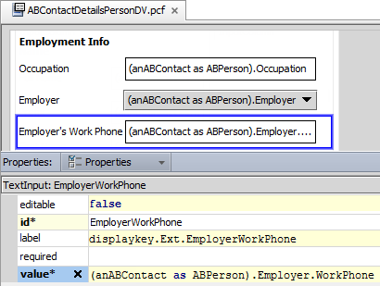

(anABContact as ABPerson).Employer.WorkPhone

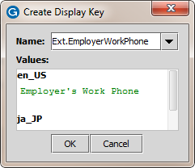

Employer's Work Phone

1. Configure targeted Post On Change
2. Configure the Employer widget targeted Post On Change properties so that only data is refreshed for the page.

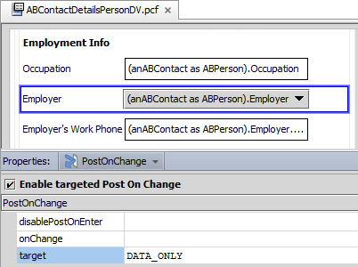

DATA_ONLY

Verification

1. Verify the modified widget behavior
2. In TrainingApp, deploy your changes to the PCF file.
3. Search for a contact with an employer, for example, William Andy.
4. In the side bar menu, select Details.
5. Click Edit.
6. Change the selection in the Employer field.
7. Verify that the Employer Phone number field changes.
8. Click Cancel.
9. Advanced targeted Post On Change

In this exercise, you will modify the InteractionPopup. First, you will add an input set as a container for several of the existing widgets. Next, you will write an expression for an input set property that shows the widget when there is an InteractionDate value. Then, you will configure targeted Post On Change to re-render the layout and show the widgets in the input set when there is an InteractionDate value.

Investigation

1. View the current widget behavior
2. In Guidewire Studio, if the server is not already running, debug the server.
3. In TrainingApp, search for a contact with interactions, such as William Andy.
4. In the side bar menu, select Interactions.
5. Click Edit and then click Add.
6. Complete the fields for an interaction.
7. Open the PCF to configure in Guidewire Studio
8. To open the PCF, use ALT+SHIFT+E.

Configuration

1. Add a new Input Set widget
2. In the InteractionPopup, add an Input Set widget below the InteractionDate input widget.
3. Specify the id property for the Input Set widget, such as InteractionInputSetID.
4. Move widget into the Input Set
5. Move the following widgets into the input set:
   * InitiatedByContact
   * ChannelDirection
   * ChannelType
   * Summary
   * User
6. Modify an Input Set widget property
7. Write an expression for the property that shows the Input Set when there is a value for the InteractionDate field.

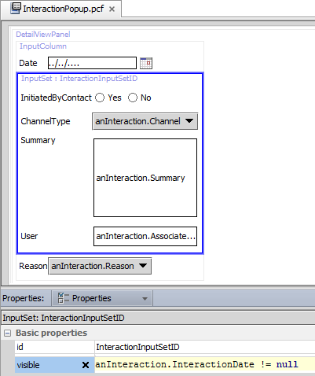

anInteraction.InteractionDate != null

1. Configure targeted Post On Change
2. Configure the required targeted Post On Change properties for a widget so that when a date is entered, the Input Set widget is visible.

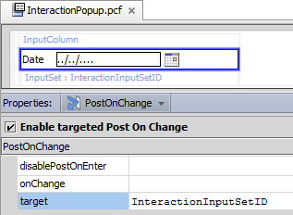

InteractionInputSetID

Verification

1. Verify the modified widget behavior
2. In TrainingApp, deploy your changes to the PCF file.
3. Search for a contact with interactions, such as William Andy.
4. In the side bar menu, select Interactions.
5. Click Edit and then click Add.
6. Verify that only the InteractionDate and InteractionReasons fields are visible.
7. Enter an InteractionDate.
8. Verify that the following fields are visible:
   * InitiatedByContact
   * ChannelDirection
   * ChannelType
   * Summary
   * User
9. Delete the InteractionDate.
10. Verify that the once visible fields are now hidden.
11. Click Cancel to exit the Popup. Click Cancel again to stop editing.

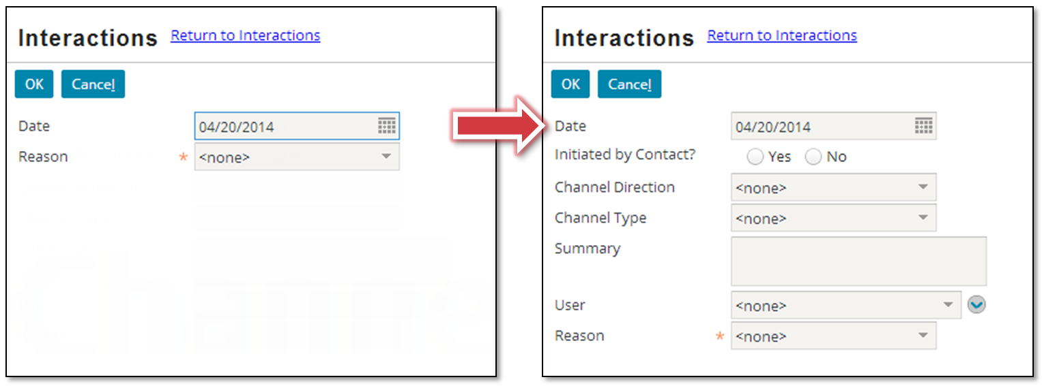

|  |  |
| --- | --- |
|  | Stop and ask your instructor to review your completed lab. |